Second Lieutenant
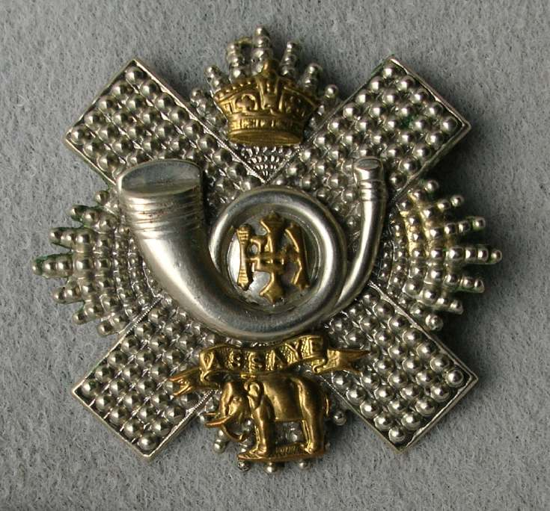
Highland Light Infantry
Cap Badge
John Edward Young
5th Battalion Highland Light Infantry

Rank: Second Lieutenant
Date of Death: 10/01/1920
Age: 33
Regiment/Service: Highland Light Infantry, 5th Bn. attd. Indian Army
Grave Reference: L. 3465.
Cemetery: CATHCART CEMETERY

Additional Information:
Son of W. F. Young, of 31, Roxburgh Circus, Cardonald, Renfrewshire, and the late Isabel Barret Waddel Young.

Country: Scotland, United Kingdom
Locality: Renfrewshire
Identified Casualties: 239

Visiting Information
This is a large cemetery in the area of Cathcart on the southern outskirts of Glasgow near Rutherglen in East Renfrewshire. The cemetery is divided in two sections the older section and newer Linn extension divided by Netherlee Road. There are war graves in both sections. Directions by road
From M77 exit at junction 2 take B 762 Barrhead Road direction east to Cathcart using Nether Aldhouse Road and Merrylee Road, after three miles turn right onto Clarkston Road B767. Head south after 200 yards turn left into Clarkston Avenue, a narrow road between houses. The main entrance to the cemetery is at the end of the road. There are tarmac roads in this site which lead to the rear entrance and Netherlee Road and the entrance to the Linn extension.
Public transport.
Several busses pass the bus stop near the cemetery entrance on Clarkston Road including bus number 44 from Glasgow City Centre at Charing Cross. The nearest railway station is at Cathcart. Trains from leave from Glasgow Central Station. The cemetery is a five minute taxi journey from the train station.

