Sapper William Burns Chrystie
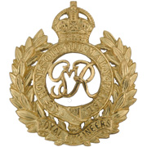
Royal Engineers
Royal Engineers
Army Number: 951

Rank: Sapper
Service No: 951
Date of Death: 30/03/1915
Regiment/Service: Royal Engineers, 1st/3rd London Field Coy.
Grave Reference: Sp. Mem. G. 12.
Cemetery: HEDGE ROW TRENCH CEMETERY

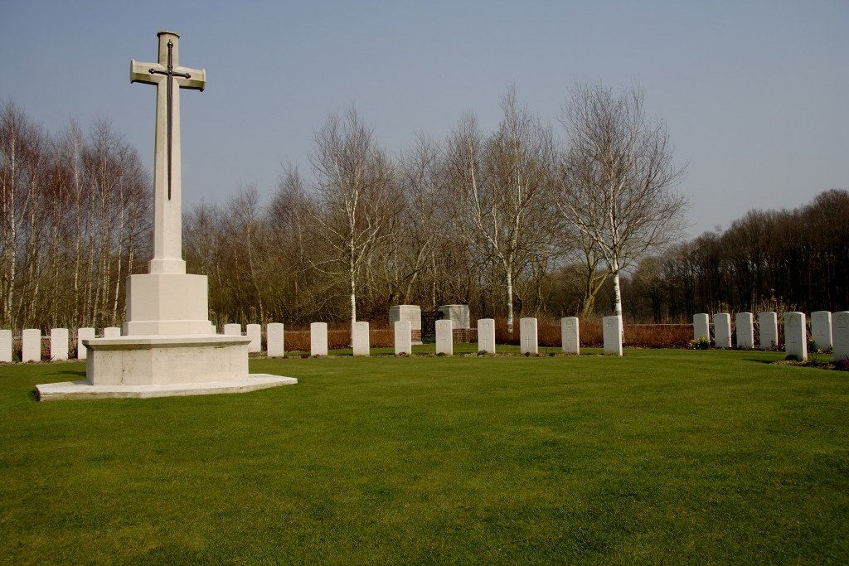
Hedge Row Trench Cemetery

Country: Belgium
Locality: West-Vlaanderen
Identified Casualties: 96

Location Information
Hedge Row Trench Cemetery is located 4 km south east of Ieper town centre, on the Verbrandemolenstraat a road leading from the Komenseweg, connecting Ieper to Komen (N336).
From Ieper town centre the Komenseweg is located via the Rijselsestraat, through the Rijselpoort (Lille Gate) and crossing the Ieper ring road, towards Armentieres and Lille. The road name then changes to Rijselseweg. 1 km along the Rijselseweg lies the left hand turning onto Komenseweg.
2.5 km along the Komenseweg lies the right hand turning onto the Vaartstraat. 900 metres along the Vaartstraat lies the left hand turning onto the Verbrandemolenstraat. 400 metres along the Verbrandemolenstraat a short distance from the road is the cemetery.

Visiting Information
Visitors to this site should note that the 100 metre grassed access path leading to this cemetery is not accessible by vehicle.
Wheelchair access to cemetery possible via main entrance. For further information regarding wheelchair access, please contact our Enquiries Section on telephone number 01628 507200.

Historical Information
The commune of Zillebeke contains many Commonwealth cemeteries as the front line trenches ran through it during the greater part of the First World War.
Hedge Row Trench Cemetery was begun in March 1915 and used until August 1917, sometimes under the name of Ravine Wood Cemetery. The cemetery suffered very severely from shell fire, and after the Armistice the positions of the individual graves could not be found or reconstructed. The headstones are therefore arranged symmetrically round the Cross of Sacrifice.
The cemetery contains 98 First World War burials.
The cemetery was designed by J R Truelove.

