Captain James Clelland Laidlaw
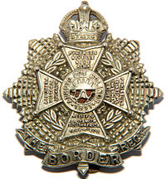
Border Regiment
Cap Badge
5th Battalion Border Regiment

Rank: Captain
Date of Death: 06/11/1917
Age: 22
Regiment/Service: Cameronians (Scottish Rifles), 3rd Bn. attd. 4th Bn. Border Regiment
Grave Reference: II. B. 5.
Cemetery: BLEUET FARM CEMETERY

Additional Information:
Son of James and M. A. Laidlaw, of Glasgow and Dalveen, Lenzie, Lanarkshire.

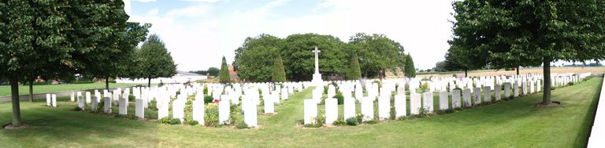
Bleuet Farm Cemetery, Belgium

Country: Belgium
Locality: West-Vlaanderen
Identified Casualties: 450

Location Information
The cemetery is located to the north west of the town of Ieper near a village called Elverdinge, this is on the N8 road between Ieper and Veurne, 3 kilometres from Ieper. Driving into the village from Ieper go to the traffic lights and turn right, this street is called Steenstraat, and after 50 metres follow the street to the right, called Boezingsestraat.
The cemetery is 500 metres along this street on the left hand side.

Visiting Information
Wheelchair access to the cemetery possible via main entrance.
For further information regarding wheelchair access, please contact our Enquiries Department on 01628 507200.

Historical Information
Bleuet Farm was used as a dressing station during 1917 Allied offensive on this front. The cemetery was begun in a corner of the farm and was in use from June to December 1917, though a few of the burials are of later date. Two graves were brought into the cemetery after the Armistice from isolated positions close by.
There are now 442 First World War burials in the cemetery and nine from the Second World War, all dating from the Allied retreat to Dunkirk in May 1940.
The cemetery was designed by Sir Reginald Blomfield.

London Gazetter
The following extracts from the London Gazette show the progress of Capyain James Clelland Laidlaw:

13th December 1916 ~ Sco Rif. The undermentioned cadets to be temp. 2nd Lts (on prob.) (attd ) :- 22 Nov. 1916. James Clelland Laidlaw.

2nd March 1917 ~ Sco. Rif.-2nd Lts. 22nd Nov. 1916 :- J. C. Laidlaw.

26th September 1917 ~ Border Regt. - Temp. 2nd Lt. J. C. Laidlaw (Sco. Rif.)
to be actg. Capt. (additional). 20th July 1917.

