Second Lieutenant William Simpson Laidlaw
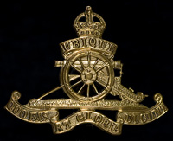
Royal Artillery
Cap Badge
Royal Field Artillery

Rank: Second Lieutenant
Date of Death: 30/08/1918
Age: 19
Regiment/Service: Royal Field Artillery, 250th Bde.
Panel Reference: Panel 3 and 4.
Memorial: VIS-EN-ARTOIS MEMORIAL

Additional Information:
Son of James and Margaret Annie Laidlaw, of Dalveen Lenzie, Glasgow.

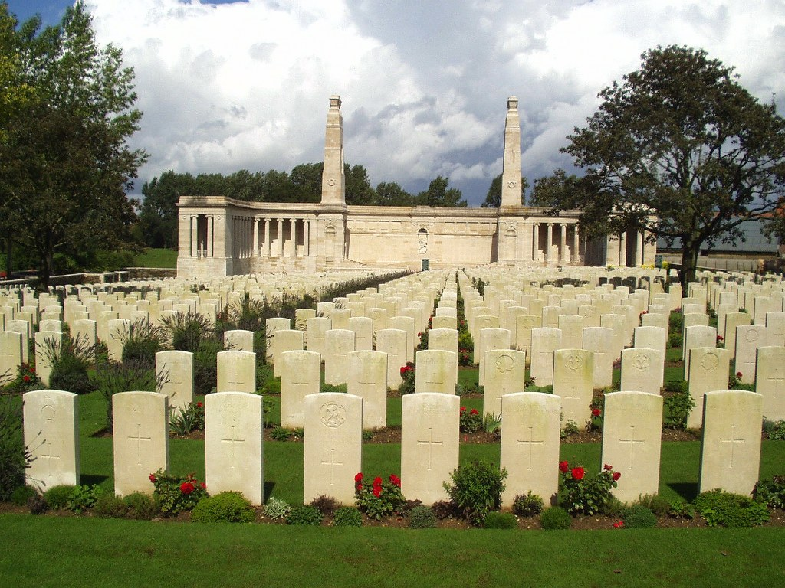
Vis-En-Artois Memorial, France

Country: France
Locality: Pas de Calais
Identified Casualties: 9825

Location Information
Vis-en-Artois and Haucourt are villages on the straight main road from Arras to Cambrai about 10 kilometres south-east of Arras.
The Memorial is the back drop to the Vis-en-Artois British Cemetery, which is west of Haucourt on the north side of the main road.
Visiting Information
The Panel Numbers quoted at the end of each entry relate to the panels dedicated to the Regiment served with. In some instances where a casualty is recorded as attached to another Regiment, his name may alternatively appear within their Regimental Panels. Please refer to the on-site Memorial Register Introduction to determine the alternative panel numbers if you do not find the name within the quoted Panels.

Historical Information
This Memorial bears the names of over 9,000 men who fell in the period from 8 August 1918 to the date of the Armistice in the Advance to Victory in Picardy and Artois, between the Somme and Loos, and who have no known grave. They belonged to the forces of Great Britain and Ireland and South Africa; the Canadian, Australian and New Zealand forces being commemorated on other memorials to the missing.
The Memorial consists of a screen wall in three parts. The middle part of the screen wall is concave and carries stone panels on which names are carved. It is 26 feet high flanked by pylons 70 feet high. The Stone of Remembrance stands exactly between the pylons and behind it, in the middle of the screen, is a group in relief representing St George and the Dragon. The flanking parts of the screen wall are also curved and carry stone panels carved with names. Each of them forms the back of a roofed colonnade; and at the far end of each is a small building.
The memorial was designed by J.R. Truelove, with sculpture by Ernest Gillick. It was unveiled by the Rt. Hon. Thomas Shaw on 4 August 1930.

London Gazette
The following is an extract from the London Gazetter:

9th April 1918 ~ War Office, 12th April, 1918. SPECIAL RESERVE OF OFFICERS.
The undermentioned, from Officer Cadet Units, to be 2nd Lts.:- ROYAL FIELD ARTILLERY. 6th Apr. 1918. William Simpson Laidlaw.

