Private Douglas Donald MacVean
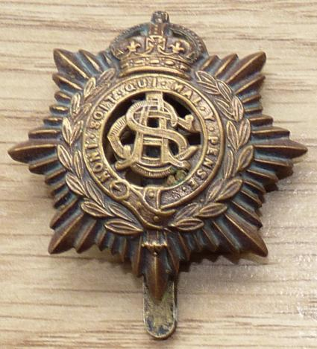
Royal Army Service Corps
Cap Badge
Army Service Corps (M.T.)
Army Number: M2/120361

Rank: Private
Service No: M2/120361
Date of Death: 24/06/1916
Regiment/Service: Army Service Corps, 596th T.M. Coy.
Grave Reference: II. E. 6.
Cemetery: AMARA WAR CEMETERY

Country: Iraq
Identified Casualties: 3696

Location Information
Amara is a town on the left bank of the Tigris some 520 kilometres from the sea. The War Cemetery is a little east of the town between the left bank of the river and the Chahaila Canal.

Visiting Information
NOTE: Whilst the current climate of political instability persists it is not possible for the Commission to manage or maintain its cemeteries and memorials located within Iraq. Alternative arrangements for commemoration have therefore been implemented and a two volume Roll of Honour listing all casualties buried and commemorated in Iraq has been produced. These volumes are on display at the Commission's Head Office in Maidenhead and are available for the public to view.
The Commission continues to monitor the situation in Iraq and once the political climate has improved to an acceptable level the Commission will commence a major rehabilitation project for its cemeteries and commemorations.
Before considering a visit to Iraq the Commission strongly recommends that you check the advice given by the Foreign & Commonwealth Office on the travel section of their website:
www.fco.gov.uk/en/travel-and-living-abroad/travel-advice-by-country/

Historical Information
Amara was occupied by the Mesopotamian Expeditionary Force on 3 June 1915 and it immediately became a hospital centre. The accommodation for medical units on both banks of the Tigris was greatly increased during 1916 and in April 1917, seven general hospitals and some smaller units were stationed there.
Amara War Cemetery contains 4,621 burials of the First World War, more than 3,000 of which were brought into the cemetery after the Armistice. 925 of the graves are unidentified. In 1933, all of the headstones were removed from this cemetery when it was discovered that salts in the soil were causing them to deteriorate. Instead a screen wall was erected with the names of those buried in the cemetery engraved upon it. Plot XXV is a Collective Grave, the individual burial places within this are not known.
There are also seven non-war graves in the cemetery.

