Company Sergeant Major
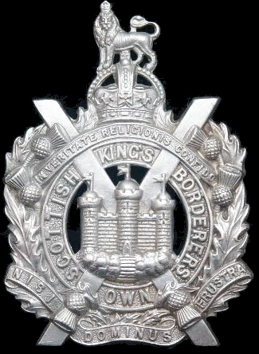
Kings Own Scottish Borderers
Cap Badge
John Kendrick Skinner
Kings Own Scottish Borderers
Army Number: 6895

Rank: Company Serjeant Major
Service No: 6895
Date of Death: 17/03/1918
Age: 35
Regiment/Service: King's Own Scottish Borderers, 1st Bn.
Awards: V C, D C M
Grave Reference: XIII. H. 15.
Cemetery: VLAMERTINGHE NEW MILITARY CEMETERY

Additional Information:
Croix de Guerre (France). Son of Walter Skinner; husband of Annie E. Y. Skinner, of 173, St. Andrew's Rd., Pollokshields, Glasgow. Native of Glasgow.

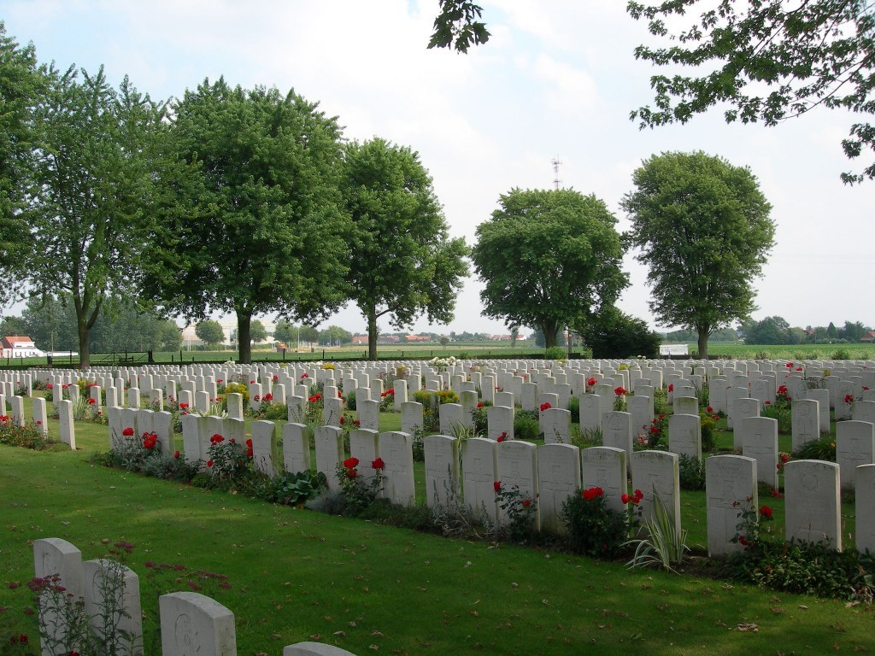
Vlamertinghe New Military Cemetery, Belgium

Country: Belgium
Locality: West-Vlaanderen
Identified Casualties: 1802

Location Information
Vlamertinghe New Military Cemetery is located 5 Kms west of Ieper town centre and to the south of the village of Vlamertinge (Vlamertinge is the modern spelling of Vlamertinghe). Vlamertinge is located along the Poperingseweg.
From Ieper town centre the Poperingseweg (N308), is reached via Elverdingsestraat then straight over two small roundabouts in the J. Capronstraat. The Poperingseweg is a continuation of J. Capronstraat and begins after a prominent railway level crossing.
The cemetery is located after turning left in the village of Vlamertinge onto the Hugo Verriestraat. This road crosses a railway and the main road N38, where the name of the street changes to Bellestraat. The cemetery lies 200 metres on the left hand side of the Bellestraat, after crossing the N38.

Visiting Information
Visitors to this site should note a grassed access path which runs between two houses on the street front and is unsuitable for vehicles.
Wheelchair access is possible via the main entrance.
For further information regarding wheelchair access, please contact our Enquiries Section on telephone number: 01628 507200

Historical Information
For much of the First World War, Vlamertinghe (now Vlamertinge) was just outside the normal range of German shell fire and the village was used both by artillery units and field ambulances. Burials were made in the original Military Cemetery until June 1917, when the New Military Cemetery was begun in anticipation of the Allied offensive launched on this part of the front in July. Although the cemetery continued in use until October 1918, most of the burials are from July to December 1917.
The cemetery now contains 1,812 Commonwealth burials of the First World War.
The cemetery was designed by Sir Reginald Blomfield.

Edinburgh Gazette
23rd February 1915 ~ His Majesty the KING has been graciously pleased to approve of the award of the Distinguished Conduct Medal to the undermentioned Warrant Officers. Non-commissioned Officers, and men for acts of gallantry and devotion to duty whilst serving with the Expeditionary Force. The particulars of the acts of gallantry will be published in the London Gazette on an early date:- 6895 Sergeant J. Skinner, 2nd Battalion, King's Own Scottish Borderers.

London Gazette
1st April 1915 ~ Citation for the Award of the Distinguished Conduct Medal
His MAJESTY THE KING has been graciously pleased to approve of the award of the Distinguished Conduct Medal to the undermentioned Warrant Officers, Non-commissioned Officers and Men, for acts of gallantry and devotion to Duty.

6895. Sergeant J Skinner, 2nd Battalion Kings Own Scottish Borderers. For conspicuous gallantry and ability at Cuinchy on 12th October, 1914.

After a very heavy engagement he reconnoitred a wood with his patrol under very difficult circumstances.

14th September 1917 ~ Citation for the Award of the Victoria Cross

No, 6895 Sjt. (Actg. C.S./M.) John Skinner, K.O. Sco. Bord. (Pollokshields,
Glasgow.) For most conspicuous bravery and good leading.

Whilst his company was attacking, machine gun fire opened on the Left flank, delaying the advance. Although C.S./M. Skinner was wounded in the head, he collected six men, and with great courage and determination worked round the left flank of three blockhouses from which the machine gun fire was coming, and succeeded in bombing and taking the first blockhouse single-handed; then, leading his six men towards the other two blockhouses, he skilfully cleared them, taking sixty prisoners, three machine guns, and two trench mortars. The dash and gallantry displayed by this warrant officer enabled' the objective to be reached and consolidated.

