Company Sergeant Major
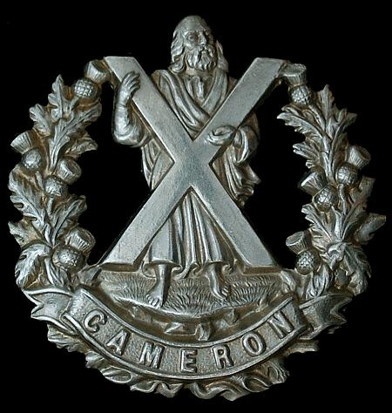
Cameron Highlanders
Cap Badge
Alexander Waddell Young
2nd Battalion Cameron Highlanders
Army Number: 4819

Rank: Company Serjeant Major
Service No: 4819
Date of Death: 25/09/1916
Age: 40
Regiment/Service: Cameron Highlanders, 1st Bn.
Grave Reference: I. F. 5.
Cemetery: FLATIRON COPSE CEMETERY, MAMETZ

Additional Information:
Son of William Fulton Young and Isabella Barret Waddel Young, of 31, Roxburgh Circus, Cardonald, Glasgow.

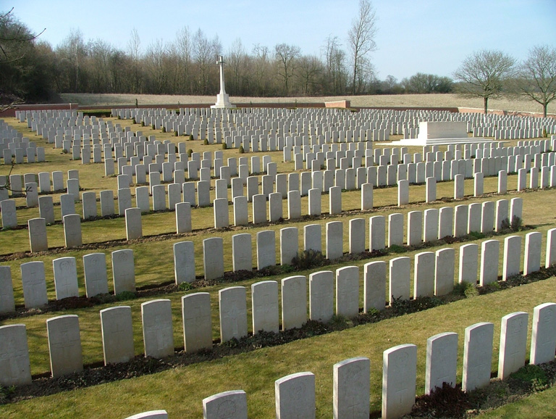
Flatiron Copse Cemetery, Mametz, Somme, France

Country: France
Locality: Somme
Identified Casualties: 1152

Location Information
Flatiron Copse Cemetery is on the right hand side of D929, Amiens-Albert-Bapaume, 10 kilometres east of Albert.
From Albert take the right turn at Y junction (102nd Infantry Brigade Memorial). It is located in the D20 just south-west of Bazentin-le-Petit. From the D929 turn south (signposted Bazentin) and on reaching the D20 T-junction turn right: the cemetery is green-signposted immediately.

Historical Information
Flatiron Copse was the name given by the army to a small plantation a little to the east of Mametz Wood.
The ground was taken by the 3rd and 7th Divisions on 14 July 1916 and an advanced dressing station was established at the copse. The cemetery was begun later that month and it remained in use until April 1917. Two further burials were made in August 1918 and after the Armistice, more than 1,100 graves were brought in from the neighbouring battlefields and from smaller cemeteries, including:-
CATERPILLAR CEMETERY, MONTAUBAN, in "Caterpillar Wood". It contained the graves of 21 soldiers from the United Kingdom who fell in July 1916, and of whom 12 belonged to the 6th and 7th Gordons.
CROSS ROADS CEMETERY, BAZENTIN, near the cross-roads at the North end of Bazentin-le-Grand. Here were buried 15 soldiers from the United Kingdom and four from New Zealand, who fell in 1916-1917.
MAMETZ WOOD CEMETERY, outside the Western edge of Mametz Wood, in which 18 soldiers from the United Kingdom were buried in 1916.
QUADRANGLE CEMETERY, BAZENTIN, between Bottom Wood and Mametz Wood, named from a small rectangular copse. Here were buried, in 1916, 32 soldiers from the United Kingdom and three from Australia, of whom 22 were artillerymen.
VALLEY CEMETERY, MONTAUBAN, between the Briqueterie and Maltzhorn Farm, in which 72 soldiers from the United Kingdom were buried in August and September, 1916.
VILLA WOOD CEMETERIES No.1 and No.2, CONTALMAISON, near a small copse North of Mametz Wood. They contained the graves of 62 soldiers from the United Kingdom who fell in 1916.
Almost all the concentrated graves are those of men who died in the summer and autumn of 1916.
There are now 1,572 Commonwealth servicemen of the First World War buried or commemorated in this cemetery. 420 of the burials are unidentified but there are special memorials to 36 casualties known or believed to be buried among them, and nine buried in Mametz Wood Cemetery whose graves were destroyed by shell fire.
The cemetery was designed by Sir Herbert Baker.

